Overview:

1. E-mailed ANU about namespace “anu_am”. Got a response about a day ago.
2. E-mailed ANU asking how the data is read into the code
3. Each one of the source codes read the data in the same way with the same format
4. Metadata is written in JavaScript

Details:

1. “namespace anu_am” contains different math identifiers since it was created for the Department of Applied Mathematics. What this means is that they have pretty much set up what the terms like “CubicalComplex,” “pores,” and “skeleton” mean in the code.
2. I have discovered that each main C source code gathers the data by reading in some kind of file. The code uses an command that is called “readFileInfo.” This is where things become a little difficult to understand. The section that is in the parentheses is usually where the file is located (e.g. “C:\Users\Chris\Documents” or “SomeTextFile.txt”). I would like to believe that by field path, they mean some kind of path that leads to a file, similar to my first example. Because of this, I have emailed them to clarify if my assumption is correct.

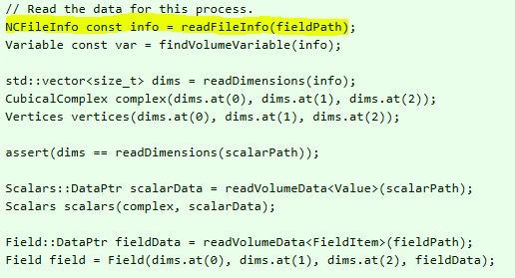

1. I have also discovered that all of the source code has the same way of reading in data from the file. What this means is that once I figure out how the input file is read, the same process can be used in all of the source codes.
2. The metadata is written in JavaScript at the very end of the code.